Test Case: tc005_SPX_Dev5_Crear_Requisicion_Spot_Con_FAD_Tipo_Cobro_Project
Step 1 - Enter username and password and click to button Enter: Credentials Entered
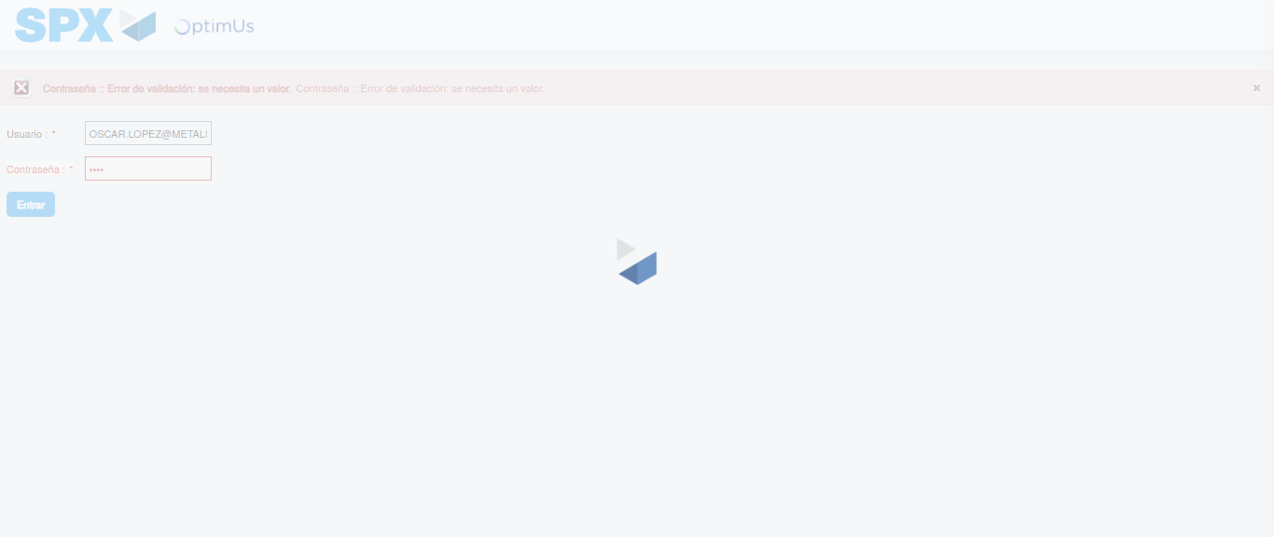Image file-name: QC_Testing-tc005_SPX_Dev5_Crear_Requisicion_Spot_Con_FAD_Tipo_Cobro_Project-1784570826505

Step 2 - Select to UEN and Access to Spot Buy Requisitions : UEN Correctly selected and Correct access
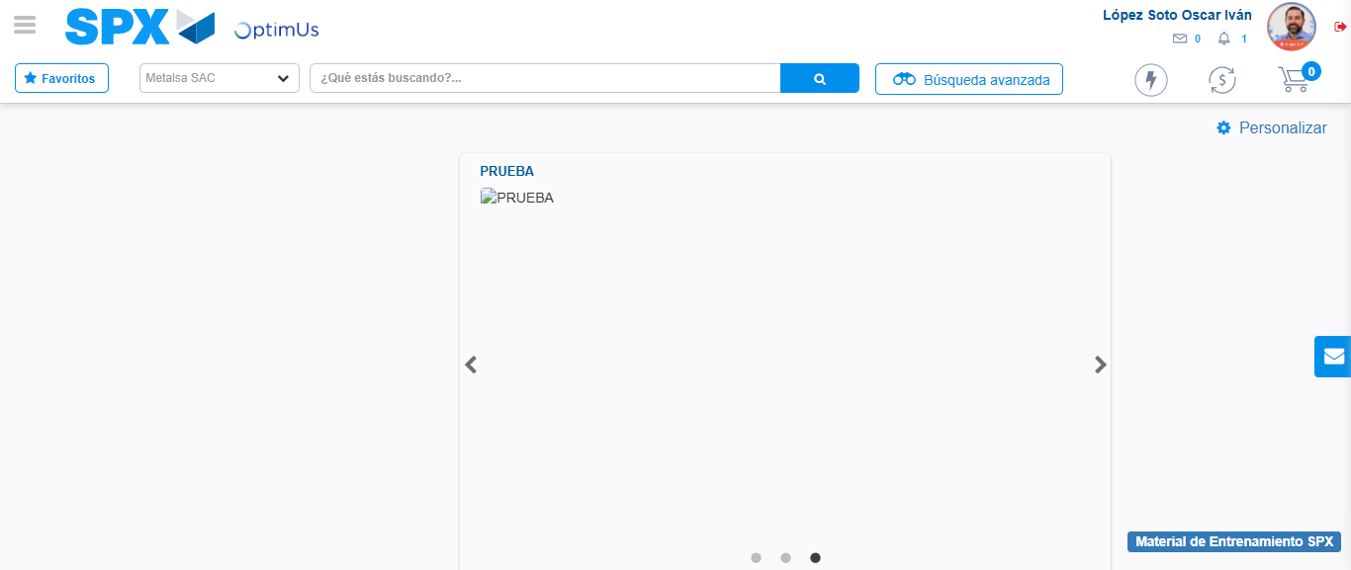Image file-name: QC_Testing-tc005_SPX_Dev5_Crear_Requisicion_Spot_Con_FAD_Tipo_Cobro_Project-1784570913254

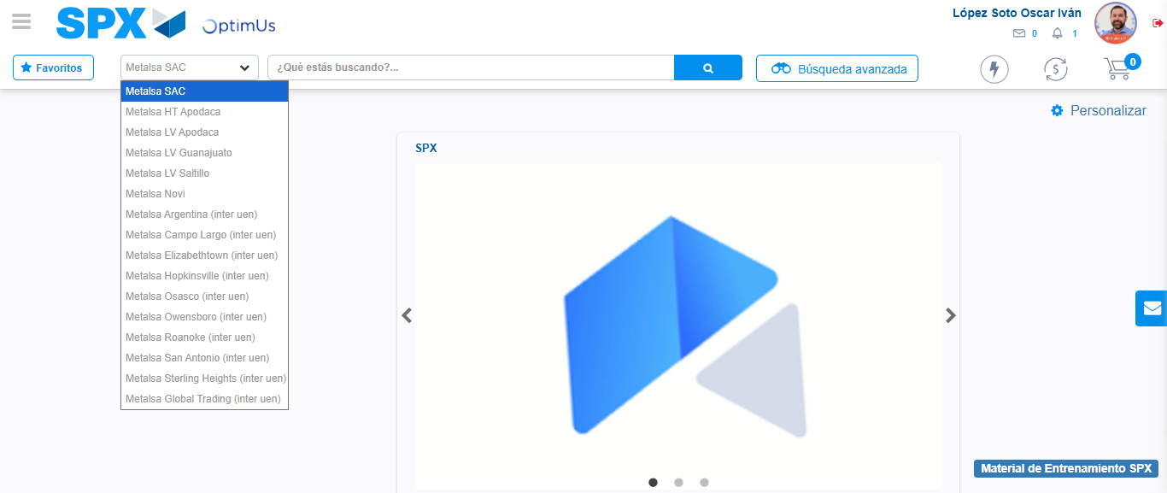Image file-name: QC_Testing-tc005_SPX_Dev5_Crear_Requisicion_Spot_Con_FAD_Tipo_Cobro_Project-1784570915935

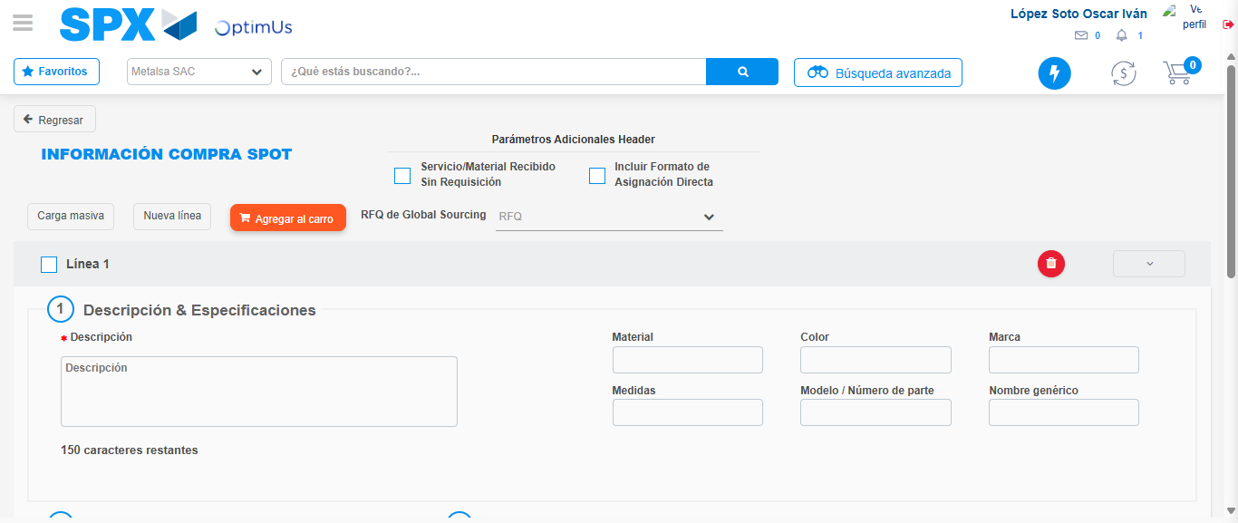Image file-name: QC_Testing-tc005_SPX_Dev5_Crear_Requisicion_Spot_Con_FAD_Tipo_Cobro_Project-1784570943343

Step 3 - Add FAD to Requisition: FAD Successfully Added
Image file-name: QC_Testing-tc005_SPX_Dev5_Crear_Requisicion_Spot_Con_FAD_Tipo_Cobro_Project-1784570943642

Image file-name: QC_Testing-tc005_SPX_Dev5_Crear_Requisicion_Spot_Con_FAD_Tipo_Cobro_Project-1784570943903

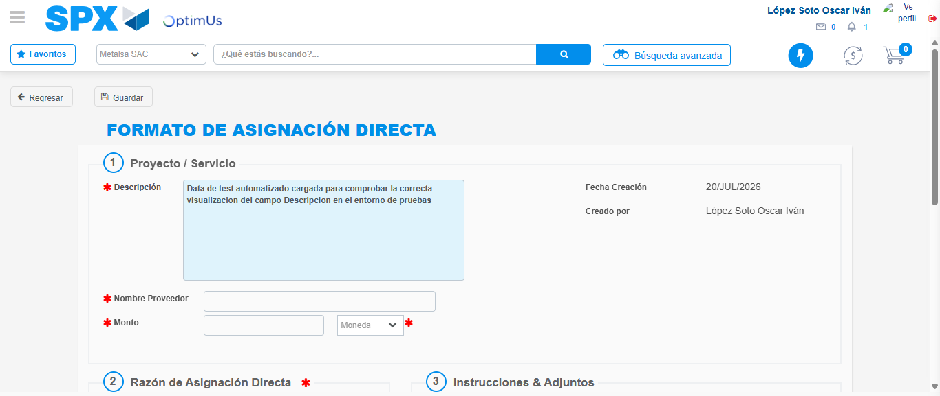Image file-name: QC_Testing-tc005_SPX_Dev5_Crear_Requisicion_Spot_Con_FAD_Tipo_Cobro_Project-1784570947050

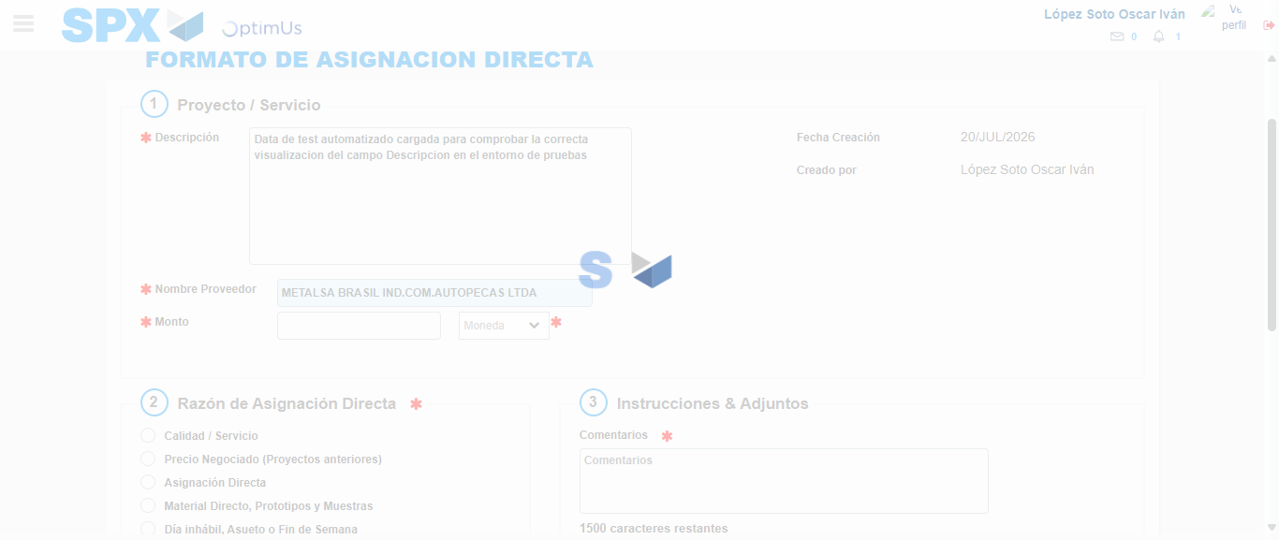Image file-name: QC_Testing-tc005_SPX_Dev5_Crear_Requisicion_Spot_Con_FAD_Tipo_Cobro_Project-1784570954303

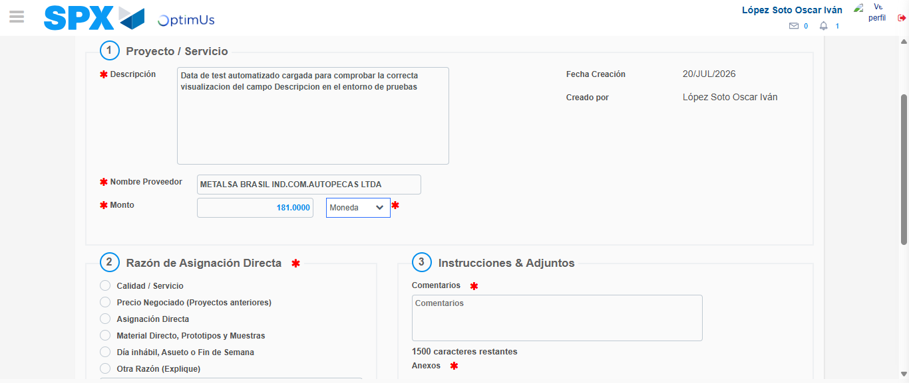Image file-name: QC_Testing-tc005_SPX_Dev5_Crear_Requisicion_Spot_Con_FAD_Tipo_Cobro_Project-1784570954786

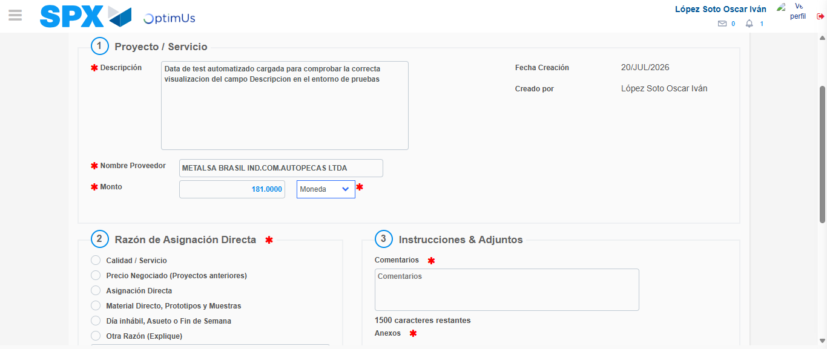Image file-name: QC_Testing-tc005_SPX_Dev5_Crear_Requisicion_Spot_Con_FAD_Tipo_Cobro_Project-1784570955020

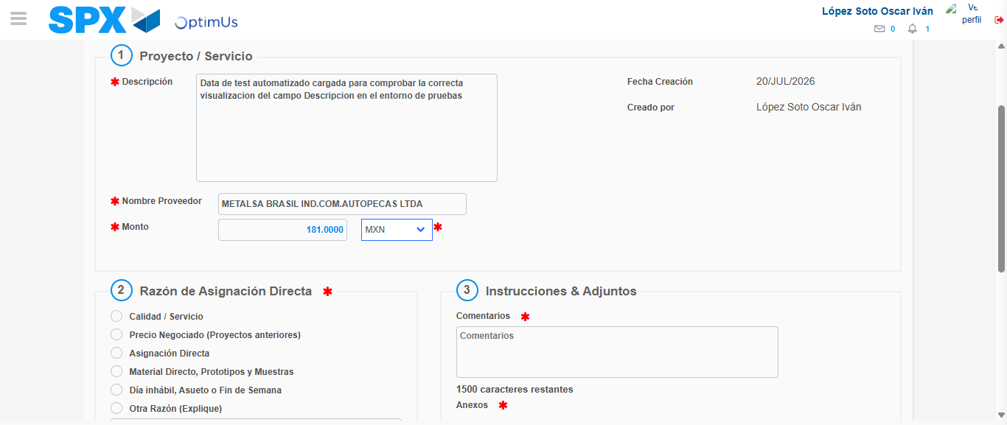Image file-name: QC_Testing-tc005_SPX_Dev5_Crear_Requisicion_Spot_Con_FAD_Tipo_Cobro_Project-1784570955496

Image file-name: QC_Testing-tc005_SPX_Dev5_Crear_Requisicion_Spot_Con_FAD_Tipo_Cobro_Project-1784570955713

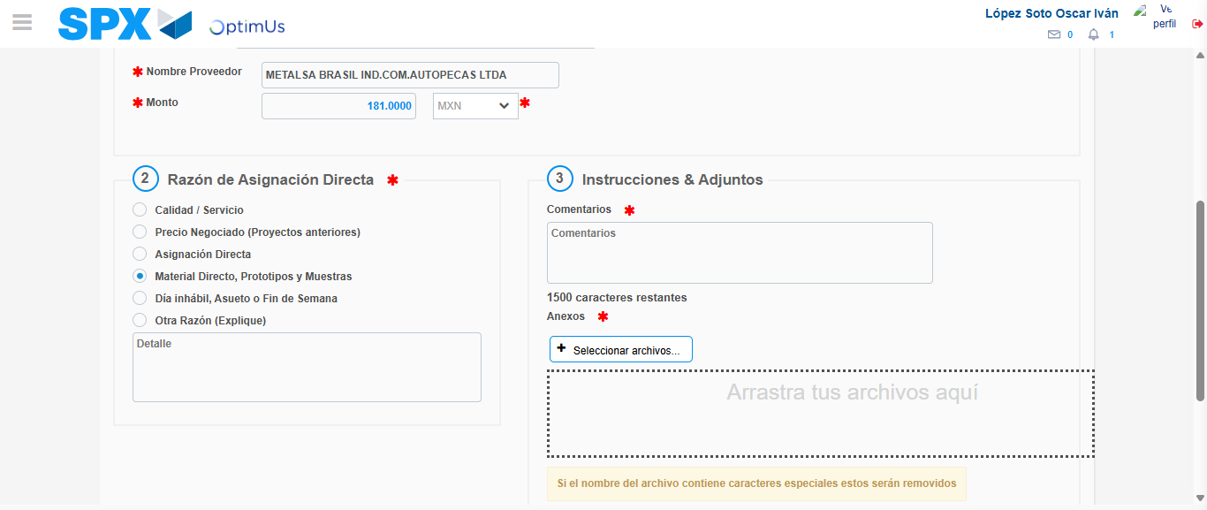Image file-name: QC_Testing-tc005_SPX_Dev5_Crear_Requisicion_Spot_Con_FAD_Tipo_Cobro_Project-1784570956763

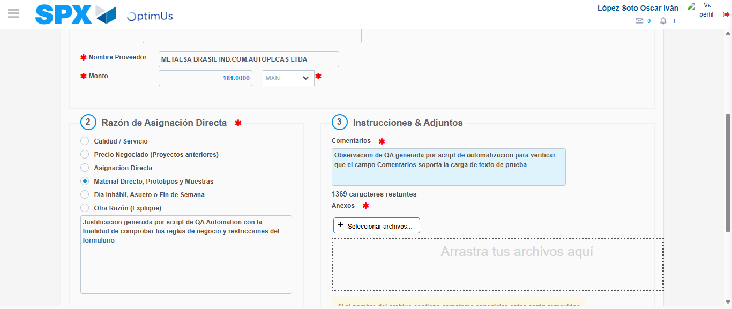Image file-name: QC_Testing-tc005_SPX_Dev5_Crear_Requisicion_Spot_Con_FAD_Tipo_Cobro_Project-1784570968200

Image file-name: QC_Testing-tc005_SPX_Dev5_Crear_Requisicion_Spot_Con_FAD_Tipo_Cobro_Project-1784570969092

Step 4 - Data Capture Spot Buy Requisition: Data captured correctly
Image file-name: QC_Testing-tc005_SPX_Dev5_Crear_Requisicion_Spot_Con_FAD_Tipo_Cobro_Project-1784570943642

Image file-name: QC_Testing-tc005_SPX_Dev5_Crear_Requisicion_Spot_Con_FAD_Tipo_Cobro_Project-1784570943903

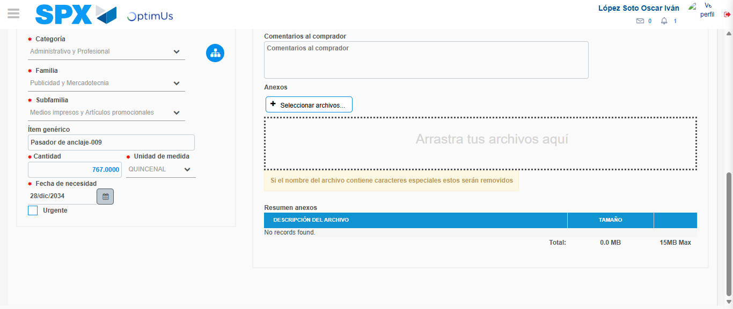Image file-name: QC_Testing-tc005_SPX_Dev5_Crear_Requisicion_Spot_Con_FAD_Tipo_Cobro_Project-1784570984202

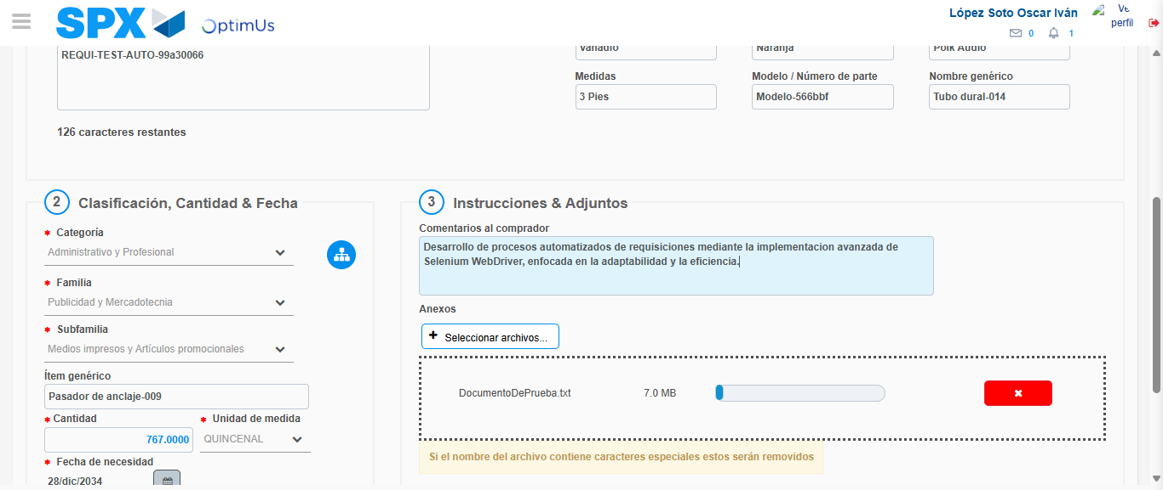Image file-name: QC_Testing-tc005_SPX_Dev5_Crear_Requisicion_Spot_Con_FAD_Tipo_Cobro_Project-1784570985133

Step 8 - Return to Main Page SPX : Return to Main Page SPX
Image file-name: QC_Testing-tc005_SPX_Dev5_Crear_Requisicion_Spot_Con_FAD_Tipo_Cobro_Project-1784570913254

Image file-name: QC_Testing-tc005_SPX_Dev5_Crear_Requisicion_Spot_Con_FAD_Tipo_Cobro_Project-1784570915935

Image file-name: QC_Testing-tc005_SPX_Dev5_Crear_Requisicion_Spot_Con_FAD_Tipo_Cobro_Project-1784570943343

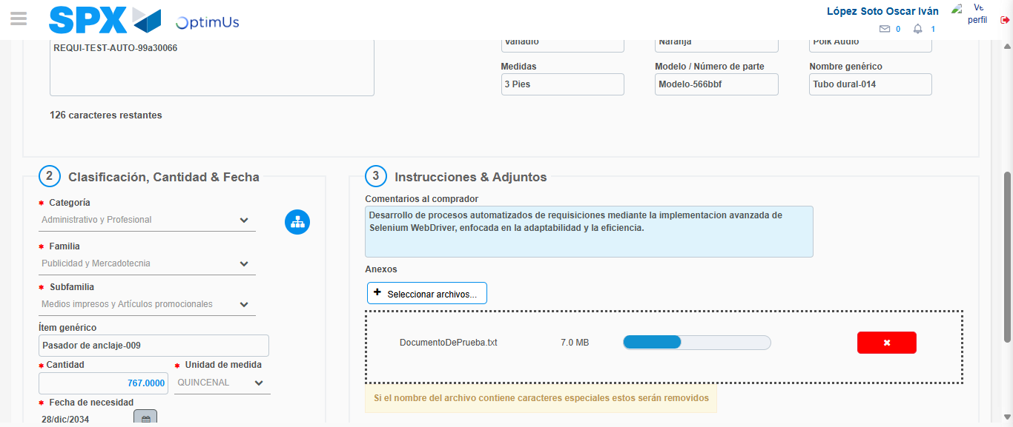Image file-name: QC_Testing-tc005_SPX_Dev5_Crear_Requisicion_Spot_Con_FAD_Tipo_Cobro_Project-1784570987389

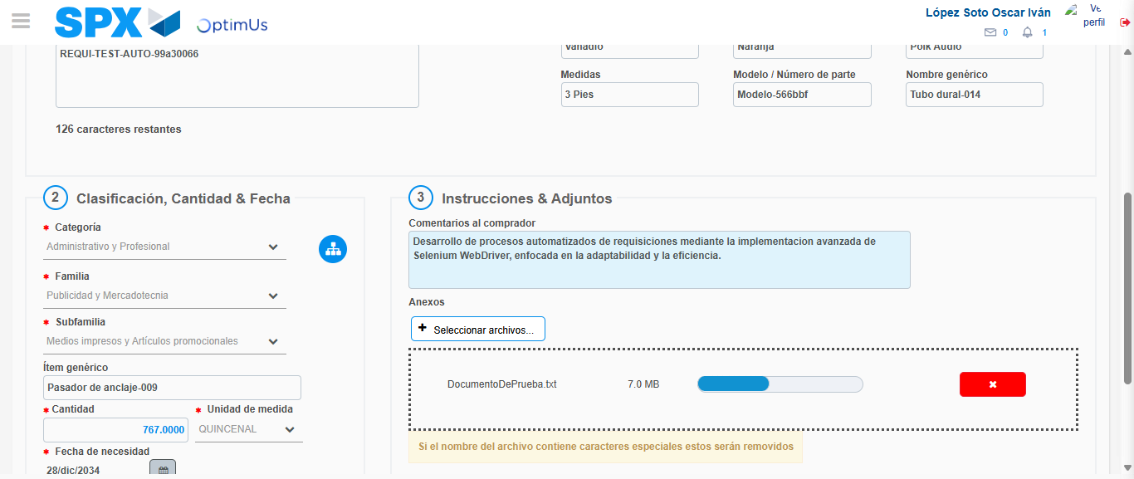Image file-name: QC_Testing-tc005_SPX_Dev5_Crear_Requisicion_Spot_Con_FAD_Tipo_Cobro_Project-1784570987593

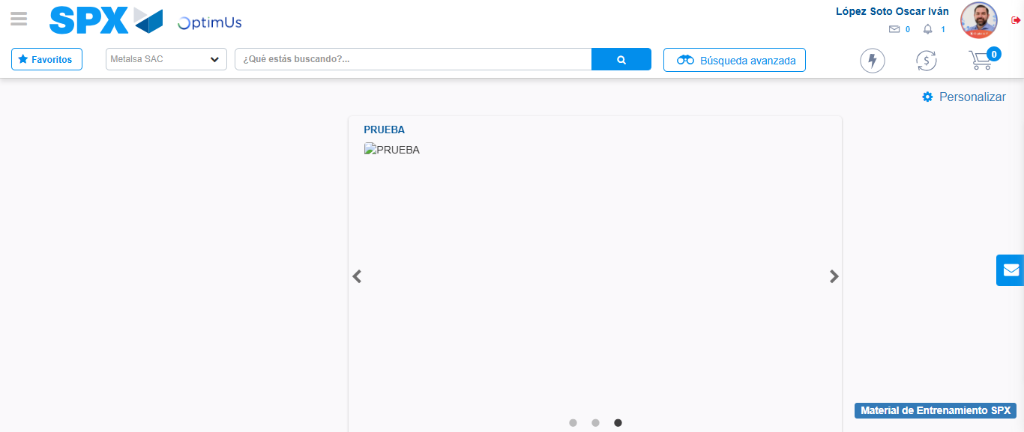Image file-name: QC_Testing-tc005_SPX_Dev5_Crear_Requisicion_Spot_Con_FAD_Tipo_Cobro_Project-1784571010199

Step 9 - Log Out : Log Out SPX
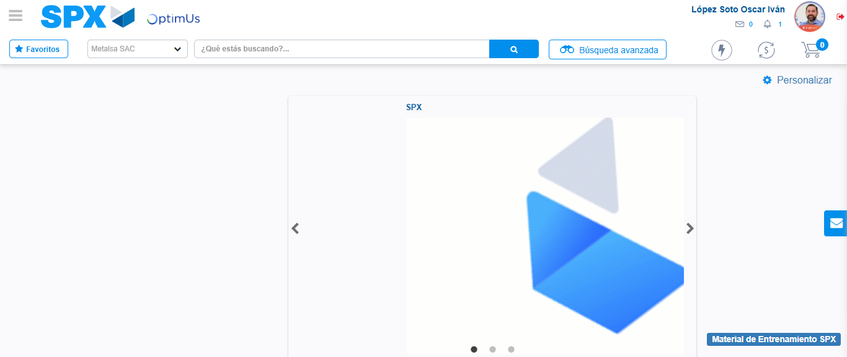Image file-name: QC_Testing-tc005_SPX_Dev5_Crear_Requisicion_Spot_Con_FAD_Tipo_Cobro_Project-1784571010565

